Design Document for:



“Old school meets new school!”™

All work Copyright ©2009 by Blake Leftwich

Written by Blake Leftwich

Version # 1.20

Sunday, July 26, 2009
Table of Contents

Name of Game 1
Game Overview 6
Philosophy 6
Respect the Brickbreaker 6
Fix the Brickbreaker 6
Evolve the Brickbreaker 6
Common Questions 6
What is the game? 6
Why create this game? 6
What do I control? 6
What is the main focus? 6
What’s different? 7
Feature Set 8
General Features 8
Game play 8
The Game World 9
Overview 9
World Feature #1 9
World Feature #2 9
The Physical World 9
Overview 9
Key Locations 9
Travel 9
Scale 9
Objects 9
Rendering System 10
Overview 10
2D/3D Rendering 10
Camera 10
Overview 10
Camera Detail #1 10
Camera Detail #2 10
Game Engine 10
Overview 10
Game Engine Detail #1 10
Water 10
Collision Detection 10
Lighting Models 11
Overview 11
Lighting Model Detail #1 11
Lighting Model Detail #2 11
The World Layout 12
Overview 12
World Layout Detail #1 12
World Layout Detail #2 12
Game Characters 13
Overview 13
Creating a Character 13
Enemies and Monsters 13
User Interface 14
Overview 14
User Interface Detail #1 14
User Interface Detail #2 14
Weapons 15
Overview 15
Weapons Details #1 15
Weapons Details #2 15
Musical Scores and Sound Effects 16
Overview 16
Red Book Audio 16
3D Sound 16
Sound Design 16
Single Player Game 17
Overview 17
Single Player Game Detail #1 17
Single Player Game Detail #2 17
Story 17
Hours of Game-play 17
Victory Conditions 17
Multi-player Game 18
Overview 18
Max Players 18
Servers 18
Customization 18
Internet 18
Gaming Sites 18
Persistence 18
Saving and Loading 18
Character Rendering 19
Overview 19
Character Rendering Detail #1 19
Character Rendering Detail #2 19
World Editing 20
Overview 20
World Editing Detail #1 20
World Editing Detail #2 20
Extra Miscellaneous Stuff 21
Overview 21
Junk I am working on… 21
“XYZ Appendix” 22
“Objects Appendix” 22
“User Interface Appendix” 22
“Networking Appendix” 22
“Character Rendering and Animation Appendix” 22
“Story Appendix” 22

Game Overview

Philosophy

Respect the Brickbreaker

The brickbreaker genre has been around since the early days of video games and is a genre proven to be marketable throughout the history of interactive entertainment. The premise works so well because of the intuitive controls and the skill involved in aiming your ball towards the bricks. PANIC will respectfully maintain the brickbreaker conventions that players have grown to love over the years.

Fix the Brickbreaker

Just because the genre is time-tested doesn’t mean it is without flaws. The original Breakout game and even the popular Arkanoid series still gives you no control over that vital first shot at the beginning of each level. PANIC allows players to aim their shots with a simple but skill-based timing method. PANIC also features an unparalleled amount of control over the ball reflection angle and mid-air tilting. These improvements are designed to empower the user.

Evolve the Brickbreaker

Many brickbreaker titles have attempted to enhance the genre by adding power ups but have only succeeded in moving away from what makes the game fun-skillful aiming and quick reflexes. PANIC wants to take these attributes and expand upon them. So what can you do with a ball and a paddle? Add gravity and velocity! Add score multipliers! Add bonus levels and more enemies. The possibilities are endless!

Common Questions

What is the game?

PANIC is a brickbreaker that challenges the player to clear three consecutive waves of bricks while trying to get the highest possible score using a brand new risk/reward multiplier system. The ball in PANIC is influenced by gravity and velocity and enemies with unique movement patterns and abilities offer variety and a chance to score more points. The player is rewarded each forth screen with a fun and unique bonus stage. The game also includes a variety of options that allow players to select difficulty levels, classic modes of play and minigames.

Why create this game?

Brickbreakers have for decades been an interactive entertainment staple pulling in hardcore and casual players before these terms were even defined. The style of game has an easy but addictive quality that never gets tired. That said, the genre has followed a certain mold for decades despite the fact that there are many possibilities to expand the gameplay. The point of PANIC is to capitalize on the popular gameplay while pushing the limits of what a brickbreaker can do in order to create a new engaging franchise.

What do I control?

You are in control of the paddle. The paddle is an extension of your reflexes and you use it to control the reflection angle of a free-bouncing ball. The paddles moves left and right in unison with your mouse and the left mouse button cashes in your points and slows the ball.

What is the main focus?

The goal is to bounce the ball up the screen and break all the bricks while attaining the highest possible score. Each bounce increases the ball speed and multiplier so as the action gets faster, your score potential goes higher. If the ball falls past the paddle off the bottom of the screen, the player loses a ball. Users can avoid this by left clicking the mouse to cash in their multiplier and slow the ball to its initial velocity.

What’s different?

No brickbreaker before has added gravity to the mix. The addition of gravity and change in velocity give the player the sense of interacting with a real ball. The multiplier creates an addictive mechanic that pushes players to test their skill and keeps them coming back to best their highest score. Bonus stages reward players with a fun new use of the paddle and ball and are playable from the main menu as minigames. PANIC also offers enemies with more depth quick wave to wave transistions and ball tilting.

Feature Set

General Features

Ball physics
Bonus stages
Clean visuals
Arcade-like audio experience
Classic mode

Gameplay

Unlimited angle ball reflection control
Skill based first shot direction control
Mid-air ball tilting
Risk/reward multiplier scoring system
Full-featured Juggling game
Full-featured Baseball game
Full-featured Vong (Pong) game
Full-featured Target sharpshooting game
Two types of ball: Dynamo and Classic
Classic mode for genre purist gameplay
Varied enemies with unique patterns, destroy methods and scoring opportunities
Quick level transitions for keeping the ball action in play.

The Game World

Overview

Panic takes place on a simple plane with clean lines and colors to represent pure gameplay. It is accompanied by retro sounds and melodies.

Brick Layouts

Bricks are arranged in increasingly challenging and interesting patterns designed to be visually stimulating while offering a dynamic playspace for the ball to bounce around in.

Visual and Audio Style

The graphics and audio in PANIC are designed to instill a sense of “easy to learn, difficult to master”. The cleanly lines and colors remind the player that there are no barriers between themselves and the challenge. The world is not muddled with distractions that detract from the pure gameplay. The audio is a throwback to classic games. An intense melody throbs in the background to exemplify the intensity of the game and sound effects are unique and memorable. The type of authentic bleeps and bloops you would continue to hear in your mind after the game ends-not just stock sound effects.

The Physical World

Overview

The playspace consists of a rectangular box. The boundaries at the top and sides are shown with a clean bluish line, The ball, paddle and enemies cannot pass this barrier and usually bounce off. Another rectangle at the top is reserved for score information. The bottom of the stage has no boundary-the ball can freely pass off the screen here causing the player to lose a life. Bricks and other interactive elements are all encased inside this rectangular space. Under the paddle is space for other UI elements.

Key Locations

Twerp waves are designed specifically for the Twerp enemy and serve as tracks for the creature to roll down toward the enemy. These wave spread out the bricks for interesting bounces in contrast to the traditional compact brick patterns.

Robot levels pit the paddle against a giant robotic arm at the top of the screen. The robot protects itself with layers upon layers of regenerating bricks. Players can break through the wall with careful angle control and destroy the robot. Once this happens bricks stop regenerating and the wave can be cleared.

Baseball bonus stage has the player try to reflect the ball between the grasp of enemy gloves in the field after the ball is pitched from the pitcher’s mound. Players can score by hitting homeruns, grand slams or base hits.

Juggle bonus stage is a blank space specifically for juggling three balls.

Vong bonus stage is a blank stage for playing Pong against an opponent.

Target bonus stage places targets in hard to reach areas sometimes protected by bricks. The player only has one chance to hit each target.

Travel

The player instantly transitions from one stage to the next as soon as a screen is cleared of all bricks. The paddle stays in place while the world transforms to the next brick pattern or bonus stage before her. The ball stays in the air in its same position and maintains its current direction and speed.

Objects

The Dynamo Ball is the ball that reacts to gravity and velocity used to destroy bricks and enemies.

The Classic Ball is the ball that bounces and moves like the ball of a traditional brickbreaker. It is a square shaped ball.

The Paddle is the paddle is what the player controls to reflect the ball back up toward the bricks.

The Brick is the basic obstacle that needs to be destroyed to progress in the game.

The Twerp is an enemy that rolls back and forth downward toward the paddle. If the twerp collides with the ball he steals it and if he then falls off the screen you lose that ball.

The Robot is a robotic arm that creates infinite bricks until he is destroyed.

The Tele is an enemy that looks like a television. Once hit he lights up the screen making it difficult to see.

The Target is a bullseye that players aim at for points in the Target bonus wave.

The Opponent is an enemy paddle that tries to score points against you on the Vong bonus stage.

The Juggle Ball is a unique Ball that is specifically for juggling. It increases in velocity very slowly.

The Baseball Diamond is a baseball field complete with bases where the baseball bonus wave takes place.

The Glove is an obstacle you must avoid when hitting the ball on the baseball wave. If gloves catch the ball an out is counted. Three outs and the wave is over.

The Pitcher looks identical to a glove and can catch the ball but also pitches the ball to the paddle in random directions over the plate.

See the “Objects Appendix” for a list of all the objects found in the world.

Camera

Overview

The perspective never changes. It is that of a traditional view of brickbreaker games.

Game Engine

Overview

The game code and graphics are created in Flash.

Format

PANIC will be displayed on any browser with a Flash plug in. This allows the game to be scaled with no loss of quality.

Collision Detection

Flash has a limited collision detection system. This is used in conjunction with custom coding to handle the required quick and accurate collision and bounces.

The World Layout

Overview

The world has a level progression designed to be quick and rewarding to match the overall gameplay style. Players are regularly reminded of progression for a sense of success.

Naming Conventions

The game is broken into four stages consisting of three waves and a bonus stage each.

Non-Stop Transitions

Waves transition from one to the next without resetting the ball location or velocity. This keeps the multiplier climbing and action moving.

Bonus Waves

Bonus Waves are designed to offer the player a new style of gameplay. This works better than the usual boss battle since the rules and controls of the bonus waves have no limitations on creativity. That said, the key to fun bonus stages will be that they are based on the control the player has learned this far in the game or from real-world knowledge. Players should never have to stop and read instructions before a wave. Balls cannot be lost on this stage and all points scored are added to the total game score at the end of the wave.

Game Characters

Overview

Characters in PANIC represent classic gameplay of the brickbreaker. The deep control mechanics and enemy interactions are hidden by classic visuals.

Avatar

The player controls the paddle, a classic representation of gaming from its earliest day meant to represent nostalgic simplicity.

Enemies

Enemy characters are designed to be more than a simple target to aim for. Each one is unique in the way you destroy it, its movement pattern or what it can do to hinder the user. They are introduced slowly in order to maintain a focus on brick-breaker action.

See the “Objects Appendix” for a list of all the enemies found in the world.

User Interface

Overview

The game UI is simple and consists of three parts.

Score

The score is located in the upper left side of the screen above the playspace. This number only increases at the end of stages, bonus levels and when players cash in their points.

Bankbar

The bankbar is located in the lower right side of the playspace under the paddle. The format is as follows: Multiplier x Bank – ex.(21 x 3000). The multiplier increases with each bounce off of an enemy or brick. The score increases the same way but may vary based on the enemy destroyed. When the player clicks the left mouse button, the value of the multiplier times the bank value is added to the score.

Ball Number

The number of balls left is signified by ball shaped icons in the lower left part of the playspace underneath the paddle. The number of icons equals the number of balls left. A new row starts under the first one if there are more than five balls left.

Melodies and Sound Effects

Overview

The sound effects and melodies are generated from scratch in low fidelity to ensure the blips and bloops sound authentic and are memorable.

Propellerhead Reason 4

Propellerhead Reason 4 will be used to generate the sounds and audio using low fidelity settings.

Audacity

Audacity will be used to edit sounds to ensure they fulfill the requirements of the effect such as pitch, length etc.

Actionscript

Actionscript allows limited control of audio in Flash. This will be used to adjust volume and length of sounds and music when necessary as well as controlling when the sounds are triggered and when they stop.

Sound Design

The audio in PANIC is designed to represent the simple days of classic gaming. The melodies on the title screen and in each wave become more intense as the game progresses to increase tension. The sounds and melodies should be intangible-not identifiable. Creativity with lo-fi sounds will ensure a memorable sound set that the player will hear even after the game is over. No sounds will sound like stock sound effects.

Single-Player Game

Overview

The player progresses through stages by clearing the screen of bricks in three waves. Following that is a bonus stage used to gain extra points with no risk of losing a ball. The goal is to complete four stages and four bonus stages.

Difficulty Levels

There are three levels of difficulty: easy, medium and hard. The game factors that are affected by the difficulty settings are the starting speed and maximum speed of the ball, the amount of tilt and launch ball speed, the speed of enemy movement and the number of balls the player starts with.

Replayability

The game focuses on high scoring techniques. Users will play time and time again in competition with each other to best each other’s scores in the main game, classic mode and bonus wave minigames.

Progression

There are four stages that consist of three brick waves with at least one enemy encounter per stage and one bonus wave. The bonus waves occur at the end of each stage.

Length of Gameplay

The game takes approximately 15 minutes to complete on medium difficulty.

Victory Conditions

How does the player win the single-player game?

Loss Conditions

How does the player win the single-player game?

Extra Miscellaneous Stuff

Overview

Drop anything you are working on and don’t have a good home for here.

Junk I am working on…

Crazy idea #1

Crazy idea #2

Objects Appendix

This appendix displays a picture and description of every object encountered in the game.

Dynamo Ball

Dynamo Ball
The Brick is the basic obstacle of the game. Bricks appear in all three waves of each stage and in some bonus waves. The ball bounces off the brick and some enemies will as well while others pass through bricks. All bricks must be destroyed to progress to the next stage except on the bonus waves. Bricks can be arranged in any pattern and appear in any number.

Classic Ball

Classic Ball
The Brick is the basic obstacle of the game. Bricks appear in all three waves of each stage and in some bonus waves. The ball bounces off the brick and some enemies will as well while others pass through bricks. All bricks must be destroyed to progress to the next stage except on the bonus waves. Bricks can be arranged in any pattern and appear in any number.

Juggle Ball

Juggle Ball
The Brick is the basic obstacle of the game. Bricks appear in all three waves of each stage and in some bonus waves. The ball bounces off the brick and some enemies will as well while others pass through bricks. All bricks must be destroyed to progress to the next stage except on the bonus waves. Bricks can be arranged in any pattern and appear in any number.

Paddle

Paddle
The Brick is the basic obstacle of the game. Bricks appear in all three waves of each stage and in some bonus waves. The ball bounces off the brick and some enemies will as well while others pass through bricks. All bricks must be destroyed to progress to the next stage except on the bonus waves. Bricks can be arranged in any pattern and appear in any number.

Brick

Brick
The Brick is the basic obstacle of the game. Bricks appear in all three waves of each stage and in some bonus waves. The ball bounces off the brick and some enemies will as well while others pass through bricks. All bricks must be destroyed to progress to the next stage except on the bonus waves. Bricks can be arranged in any pattern and appear in any number.

Twerp


Twerp
The Brick is the basic obstacle of the game. Bricks appear in all three waves of each stage and in some bonus waves. The ball bounces off the brick and some enemies will as well while others pass through bricks. All bricks must be destroyed to progress to the next stage except on the bonus waves. Bricks can be arranged in any pattern and appear in any number.

Robot


Robot
The Brick is the basic obstacle of the game. Bricks appear in all three waves of each stage and in some bonus waves. The ball bounces off the brick and some enemies will as well while others pass through bricks. All bricks must be destroyed to progress to the next stage except on the bonus waves. Bricks can be arranged in any pattern and appear in any number.

Tele


Tele
The Brick is the basic obstacle of the game. Bricks appear in all three waves of each stage and in some bonus waves. The ball bounces off the brick and some enemies will as well while others pass through bricks. All bricks must be destroyed to progress to the next stage except on the bonus waves. Bricks can be arranged in any pattern and appear in any number.

Opponent

Opponent
The Brick is the basic obstacle of the game. Bricks appear in all three waves of each stage and in some bonus waves. The ball bounces off the brick and some enemies will as well while others pass through bricks. All bricks must be destroyed to progress to the next stage except on the bonus waves. Bricks can be arranged in any pattern and appear in any number.

Target


Target
The Brick is the basic obstacle of the game. Bricks appear in all three waves of each stage and in some bonus waves. The ball bounces off the brick and some enemies will as well while others pass through bricks. All bricks must be destroyed to progress to the next stage except on the bonus waves. Bricks can be arranged in any pattern and appear in any number.

Glove


Glove
The Brick is the basic obstacle of the game. Bricks appear in all three waves of each stage and in some bonus waves. The ball bounces off the brick and some enemies will as well while others pass through bricks. All bricks must be destroyed to progress to the next stage except on the bonus waves. Bricks can be arranged in any pattern and appear in any number.

Baseball Diamond

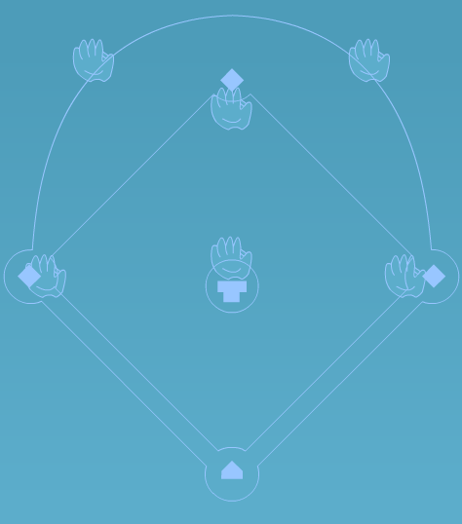
Baseball Diamond
The Brick is the basic obstacle of the game. Bricks appear in all three waves of each stage and in some bonus waves. The ball bounces off the brick and some enemies will as well while others pass through bricks. All bricks must be destroyed to progress to the next stage except on the bonus waves. Bricks can be arranged in any pattern and appear in any number.

Levels Appendix

This appendix displays a picture and description of every wave in the game.

Waves 1.1 through 1.3

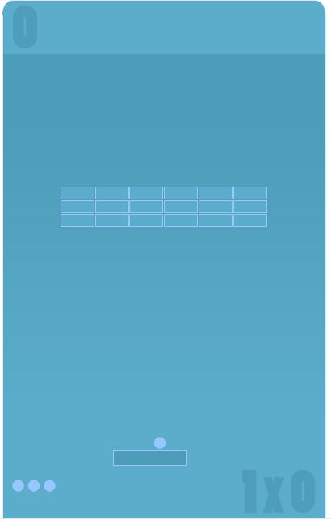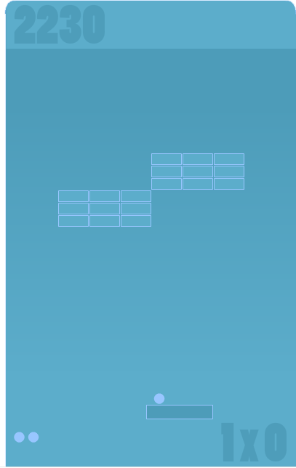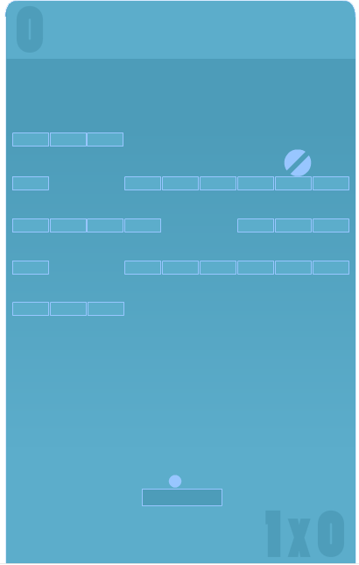
wave 1.1 wave 1.2 wave 1.3
The Brick is the basic obstacle of the game. Bricks appear in all three waves of each stage and in some bonus waves. The ball bounces off the brick and some enemies will as well while others pass through bricks. All bricks must be destroyed to progress to the next stage except on the bonus waves. Bricks can be arranged in any pattern and appear in any number.

Waves 2.1 through 2.3

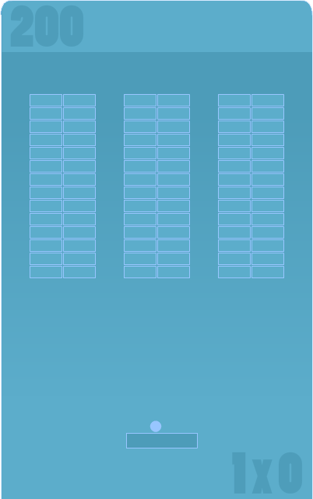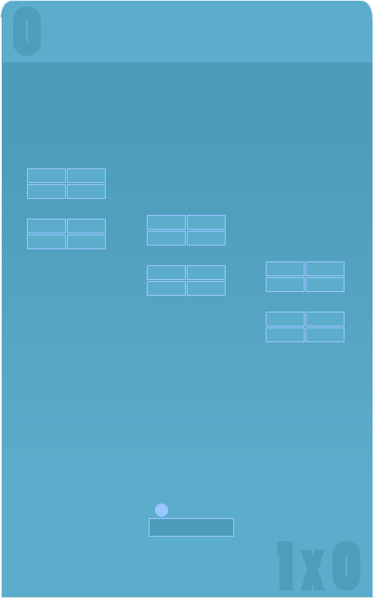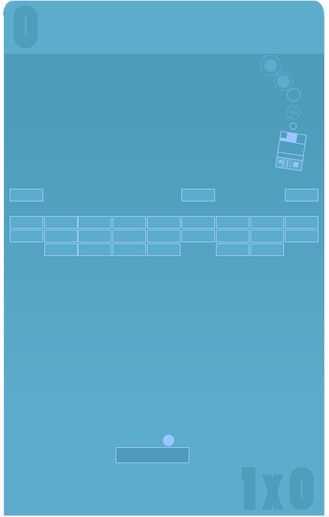
wave 2.1 wave 2.2 wave 2.3
The Brick is the basic obstacle of the game. Bricks appear in all three waves of each stage and in some bonus waves. The ball bounces off the brick and some enemies will as well while others pass through bricks. All bricks must be destroyed to progress to the next stage except on the bonus waves. Bricks can be arranged in any pattern and appear in any number.

Waves 3.1 through 3.3

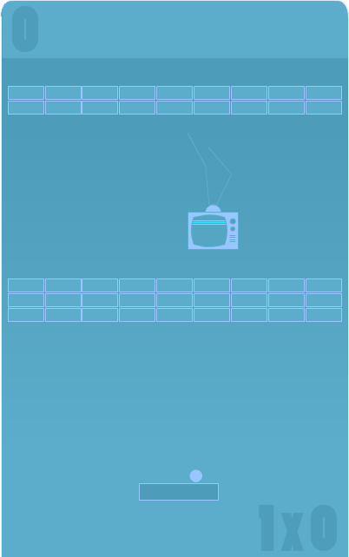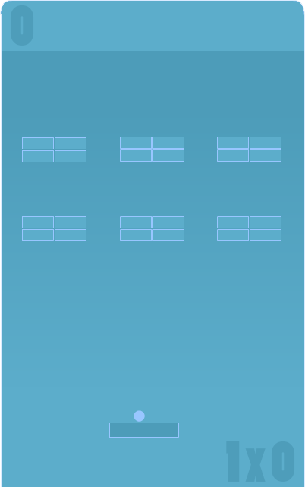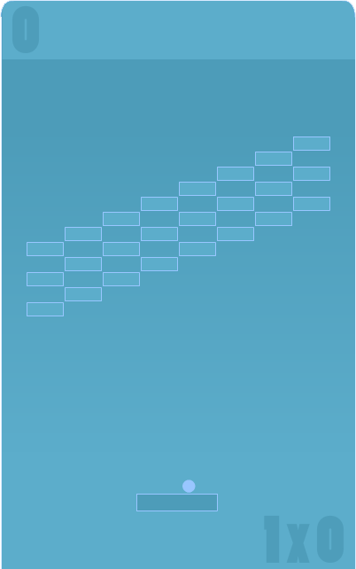
wave 3.1 wave 3.2 wave 3.3
The Brick is the basic obstacle of the game. Bricks appear in all three waves of each stage and in some bonus waves. The ball bounces off the brick and some enemies will as well while others pass through bricks. All bricks must be destroyed to progress to the next stage except on the bonus waves. Bricks can be arranged in any pattern and appear in any number.

Waves 4.1 through 4.3

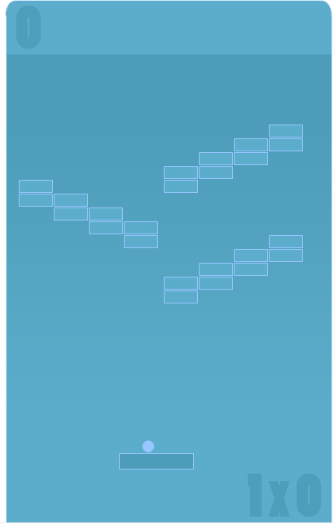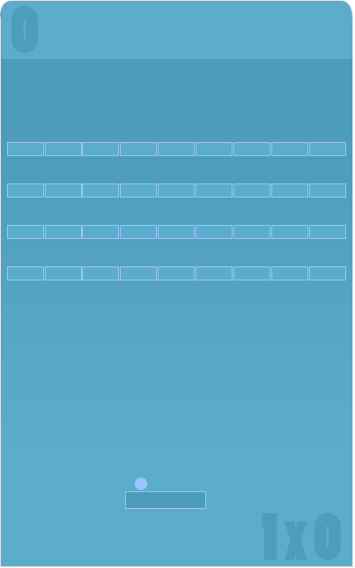
wave 4.1 wave 4.2 wave 4.3
The Brick is the basic obstacle of the game. Bricks appear in all three waves of each stage and in some bonus waves. The ball bounces off the brick and some enemies will as well while others pass through bricks. All bricks must be destroyed to progress to the next stage except on the bonus waves. Bricks can be arranged in any pattern and appear in any number.

Bonus Waves Target and Vong

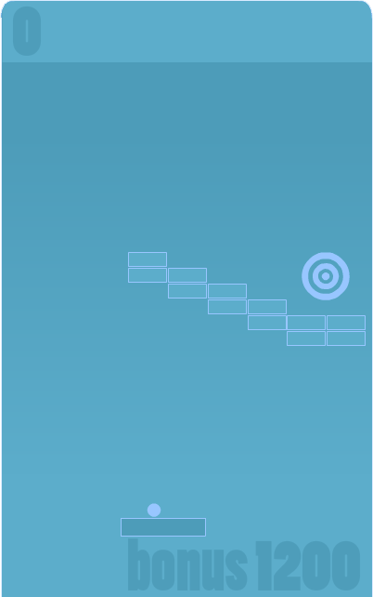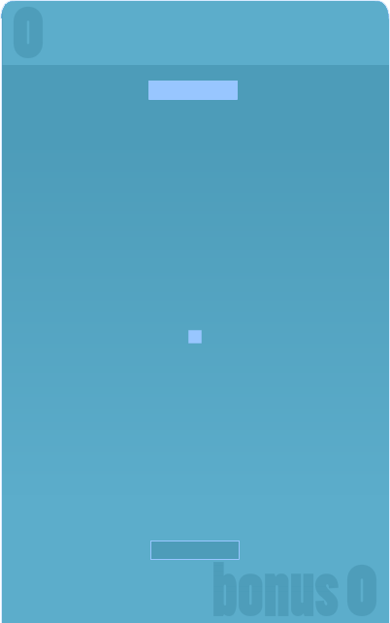
bonus wave target bonus wave vong
The Brick is the basic obstacle of the game. Bricks appear in all three waves of each stage and in some bonus waves. The ball bounces off the brick and some enemies will as well while others pass through bricks. All bricks must be destroyed to progress to the next stage except on the bonus waves. Bricks can be arranged in any pattern and appear in any number.

Bonus Waves Juggle and Baseball

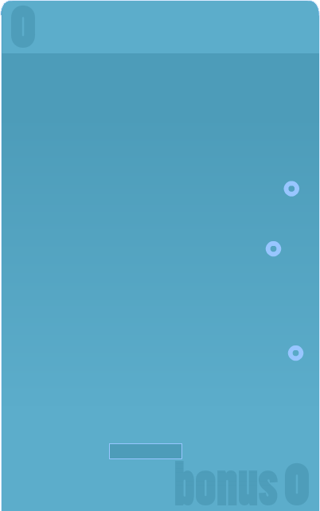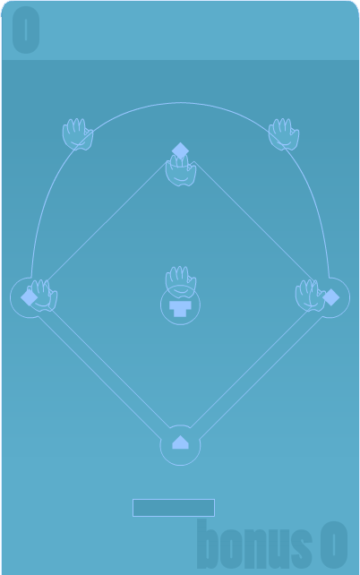
bonus wave juggle bonus wave baseball
The Brick is the basic obstacle of the game. Bricks appear in all three waves of each stage and in some bonus waves. The ball bounces off the brick and some enemies will as well while others pass through bricks. All bricks must be destroyed to progress to the next stage except on the bonus waves. Bricks can be arranged in any pattern and appear in any number.

Classic Waves


bonus wave juggle bonus wave baseball
The Brick is the basic obstacle of the game. Bricks appear in all three waves of each stage and in some bonus waves. The ball bounces off the brick and some enemies will as well while others pass through bricks. All bricks must be destroyed to progress to the next stage except on the bonus waves. Bricks can be arranged in any pattern and appear in any number.

“User Interface Appendix”

“Networking Appendix”

“Character Rendering and Animation Appendix”

“Story Appendix”

Okay, that’s it. I wanted to spend more time on this and really make it a great roadmap for putting a game design together. Unfortunately it would take a ton of time and that is something that we don’t have enough of in this business. I think you get the idea anyhow. Also, don’t get the impression that I think a design should provide the information in any particular order, this just happened to be the way it fell out of my head when I sat down. Change this template any way you want and if you feel you have improved on it, send it back to me and I can pass it out as an alternative to anyone that asks me in the future.

Good luck and all that!

Chris Taylor

